

A WTA Subject Activity Report

On

### “ONLINE GROCERY SYSTEM”

Submitted by:

POTHURI JEEVAN SAI 1RN19CS099

S LOGESH 1RN19CS119

SS KOUSHIK 1RN19CS120

RISHAD ALI 1RN19CS114

Under the Guidance of:

Mrs. Vidya Y Assistant Professor Dept. of CSE



#### CERTIFICATE

Certified that the mini project work entitled ***“*ONLINE GROCERY SYSTEM”** has been successfully carried out by **POTHURI JEEVAN SAI** bearing USN **1RN19CS099, S LOGESH** bearing USN **1RN19CS119** , **SS KOUSHIK** bearing USN **1RN19CS120, RISHAD ALI** bearing USN **1RN19CS114,** bonafide students of **RNS Institute of Technology** in partial fulfillment of the requirements for the **6th semester** of **Bachelor of Engineering** in **Computer Science and Engineering** of **Visvesvaraya Technological University**, Belgaum, during academic year 2021- 2022.

Mrs. Vidya Y Dr. Kiran P

Assistant Professor Professor & HOD

Dept. of CSE Dept of CSE

**ACKNOWLEDGMENT**

Any achievement, be it scholastic or otherwise does not depend solely on the individual efforts but on the guidance, encouragement and cooperation of intellectuals, elders and friends. A number of personalities, in their own capacities have helped us in carrying out this project work. We would like to take this opportunity to thank them all.

We are grateful to Management and **Dr. M K Venkatesha**, Principal, RNSIT, Bangalore, for his support towards completing this mini project.

We would like to thank **Dr. Kiran P**, Professor & Head, Department of Computer Science & Engineering, RNSIT, Bangalore, for his valuable suggestions and expert advice.

We deeply express our sincere gratitude to our guide **Mrs. Vidya Y**, Assistant Professor, Department of CSE, RNSIT, Bangalore, for his able guidance, regular source of encouragement and assistance throughout this project.

We would like to thank all the teaching and non-teaching staff of Department of Computer Science & Engineering, RNSIT, Bengaluru for their constant support and encouragement

POTHURI JEEVAN SAI 1RN19CS099

S LOGESH 1RN19CS119

SS KOUSHIK 1RN19CS120

RISHAD ALI 1RN19CS114

# ABSTRACT

This project is a web based shopping system for an existing shop. The project objective is to deliver the online shopping application into android platform.

This project is an attempt to provide the advantages of online shopping to customers of a real shop. It helps buying the products in the shop anywhere through internet by using an android device. Thus the customer will get the service of online shopping and home delivery from his favorite shop. This system can be implemented to any shop in the locality or to multinational branded shops having retail outlet chains.

If shops are providing an online portal where their customers can enjoy easy shopping from anywhere, the shops won’t be losing any more customers to the trending online shops such as flipcart or ebay. Since the application is available in the Smartphone it is easily accessible and always available.

**TABLE OF CONTENTS**

**No. Chapter Page No**

**ABSTRACT i**

**LIST OF FIGURE ii**

**LIST OF TABLES iv**

**ACKNOWLEDGEMENT v**

**1 INTRODUCTION**

**1.1 OVERVIEW OF WEB DEVELOPMENT 1**

**1.2 HISTORY OF WEB DEVELOPMENT 2**

**1.3 BUSINESS ADVANTAGES OF WEB DEVELOPMENT 3**

**2 PHP**

**2.1 INTRODUCTION TO PHP 5**

**2.2 WHAT IS PHP? 5**

**2.3 IS PHP THE RIGHT LANGUAGE? 5**

**2.4 USES OF PHP 6**

**3 INTRODUCTION TO THE PROJECT**

**2.1 OVERVIEW OF THE PROJECT 7**

**2.2 AIM 7**

**4 PROBLEM STATEMENT 8**

**5 RESOURCE REQUIREMENTS**

**5.1 HARDWARE REQUIREMENTS 9**

**5.2 SOFTWARE REQUIREMENTS 9**

**6 SYSTEM DESIGN**

**6.1 What Makes Up a PHP Project? 10**

**7 IMPLEMENTATION**

**7.1 PSEUDOCODE FOR MAJOR FUNCTIONALITIES 14**

**8 RESULTS AND SNAPSHOTS 24**

**9 CONCLUSION AND FUTURE ENHANCEMENTS 27**

**REFERENCES 28**

**LIST OF FIGURES**

**No. Description Page No**

**1 Home Page 24**

**2 Categories 25**

**3 Cart 26**

|  |  |  |
| --- | --- | --- |
|  |  |  |
|  |  |  |
|  |  |  |
|  |  |  |
|  |  |  |
|  |  |  |
|  |  |  |

**Chapter 1:**

**INTRODUCTION TO WEB DEVELOPMENT**

* 1. **OVERVIEW OF WEB DEVELOPMENT**

There are two broad divisions of web development – front-end development (also called client-side development) and back-end development (also called server-side development).

Front-end development refers to constructing what a user sees when they load a web application – the content, design and how you interact with it. This is done with three codes – HTML, CSS and JavaScript.

HTML, short for **Hyper Text Markup Language**, is a special code for ‘marking up’ text in order to turn it into a web page. Every web page on the net is written in HTML, and it will form the backbone of any web application. CSS, short for **Cascading Style Sheets**, is a code for setting style rules for the appearance of web pages. CSS handles the cosmetic side of the web. Finally, **JavaScript** is a scripting language that’s widely used to add functionality and interactivity to web pages.

Web developers often work for clients who are trying to get their product or service onto the web. The work is typically very project focused and involves collaborating with a team that helps to coordinate the client’s needs into the end product. The client could be a tech company, an organization, or a government. The work could involve front-end, back-end, or full-stack web development.

Web development could be a good profession for you if you like solving logical problems, building useful things, and experimenting with new technologies. Web developers are in high demand, generally have a good work/life balance, and command comfortable salaries. Google your specific location to get a better sense of your local web development job opportunities.

* 1. **HISTORY OF WEB DEVELOPMENT**

The rise of the internet within mainstream culture is largely correlated with its history as a visual medium. Like many other computer systems and applications, it took a graphic interface to get the general population to start to understand the internet’s potential. The personal computer would not have proliferated throughout our households and work environments without the display monitor, and still did not become widely used until electronic spreadsheets, word processors and video games started attracting users. Similarly, users did not start buying into the World Wide Web until the visual- oriented web browser started coming into its own in the early 1990s. And since that time, even though there have been dramatic improvements in web technology and aesthetics, some of the earliest web design techniques have persevered throughout the years.

In 1989, Tim Berners-Lee (then a fellow at the CERN Laboratory in Europe) outlined his concept of a computer platform that could facilitate collaboration among researchers who are based in different parts of the world. This led to the invention of the Hypertext Markup Language (HTML) in 1990. Strongly based on the Standard Generalized Markup Language (SGML), HTML became the fundamental building block of the World Wide Web, and remains at the core of its coding and infrastructure. The standard enabled coders with the ability to organize web page layouts that could be understood and interacted with over interconnected networks.

The internet had long been around in some form by that point, with the first wide area

network (WAN) having been established in 1965 and the first local area network (LAN) around 1983. Twisted-pair, coaxial and fiber optic cable had been in development for many decades, and had already been broadly applied in the field of telecommunications. But when all of these technologies converged with Berners-Lee’s model, the modern web was born. Interest in the technology quickly ramped up, and the first commercial web pages were up and running by the mid- 1990s.

Prior to the Mosaic browser, much of the web’s presentation consisted of text and tables. Although not the first browser, Mosaic innovated the format by displaying text together with images in a way that defined a path for the future of web design, and served as the World Wide Web’s killer app.

Experiments ensued in the form and function of web page elements. From menu hierarchies to fonts to color schemes, web design grew into an art form that blended tech savvy with aesthetic sensitivity.

* 1. **BUSINESS ADVANTAGES OF WEB DEVELOPMENT**

With the advent of new technology, it is quite easy to miss out on esteemed opportunities available. This situation is even worse when one does not have the expertise to tap on these changes. Well, this is the scenario for businesses which have limited knowledge of website development and design.

Let’s face it, website development agency services have tremendously changed how the business industry works. So, for serious entrepreneurs or companies wishing to know the importance of websites this article provides just that.

##### Makes navigation easy

When it comes to having a successful online platform, the user must enjoy easy navigation. Essentially, information provided on the website should be easy to access. For this reason, it is expected that the pages have fast loading speeds.

Subsequently, the website like online auto parts store is required to offer options to further aid in navigation. This encompasses the inclusion of a search box. Here, the users get to type on the search tool and quickly be directed to the section. It is through exemplary web design that a developer’s website achieves this.

Aside from developing the website, the developer is advised to regularly test the pages for ease of navigation. This is to eliminate or resolve bugs that may hamper the ease of loading web pages. Remember, if a website has good navigation capabilities, then it is guaranteed of more organic traffic.

##### Provide visual content on the website

Truth be said, selling abstract product and services can be cumbersome. This is further complicated when a company only provides tons of text about their specialty. It is here that website development spices things up.

By contacting a professional web designer, the business owner gets to choose the images to use. Additionally, the enterprise has the freedom to choose the number of promo videos and images. This will be guided by the optimization on search engines.

The merit of using visual contents is that provides the users with a clear picture of what the product looks like. Apparently, not all customers understand the services or products offered through text. So, the inclusion of images makes it simple to drive the message home.

Besides this, use of images on the site easily captures the attention of the readers. Before reading through the text, users are often keen on the image. This improves the chances of having more users to the website

Nevertheless, webmasters are advised to avoid stuffing the visual data. This is because it makes it difficult for the user to interpret. It also lowers the ranking of the website of search engine optimization. So it is important to moderate the use of imagery.

##### Attract lifetime clients to your business

As the company aspires to spread its wings and expand, it is fundamental to have loyal customers. Nevertheless, this can be a daunting task especially when the entrepreneur uses poor tactics to achieve this. It is at this point that development and designing of the website help out.

The metrics retrieved from the site enable webmasters to monitor the activity of users. Here, it is possible to highlight the customers that have continuously supported the brand. After pinpointing them, the business owner ought to employ creative ways to retain these customers.

One innovative option is rewarding them with gift vouchers and rewards. This will definitely give them more reason to access your services or products. Remember, it is through the website that the business owner ensures no loyal customer is left out.

Another fascinating thing about the lifetime users is that they are able to market the brand. So they get to indirectly work for the company. This also reduces the cost of marketing

##### Improving user engagement

Conventionally, an enterprise was hosted in a brick and mortar structure. However, times have changed as more services have become digital. It is for this reason that entrepreneurs are encouraged to develop superb websites.

In this platform, it is quite easy to maintain a good rapport with the end user. This entails retrieving feedback on the services and products offered. So you can interact with them and provide vital responses to the queries asked. Additionally, there is no limitation on the time of activity. By automating the services on the website, clients are guaranteed of round the clock services.

Also under user engagement, the blog or site owner can keep customers posted at all times. For instance, if new price charges are introduced then customers are among the first to know

**Chapter 2:**

##### INTRODUCTION TO PHP

**PHP**

PHP is one of the most widely used server-side scripting language for web development. Popular websites like Facebook, Yahoo, Wikipedia etc., PHP is so popular because it's very simple to learn, code and deploy on server, hence it has been the first choice for beginners since decades.

##### WHAT IS PHP?

PHP stands for **Hypertext Pre-Processor**. PHP is a scripting language used to develop static and dynamic webpages and web applications. Here are a few important things you must know about PHP:

1. PHP is an Interpreted language; hence it doesn't need a compiler.
2. To run and execute PHP code, we need a Web server on which PHP must be installed.
3. PHP is a server-side scripting language, which means that PHP is executed on the server and the result is sent to the browser in plain HTML.
4. PHP is open source and free.

##### Is PHP the right language?

If you are still confused about whether you should learn PHP or is PHP the right language for your web project, then here we have listed down some of the features and usecases of PHP language, which will help you understand how simple yet powerful PHP scripting language is and why you should learn it.

1. PHP is **open source** and **free**, hence you can freely download, install and start developing using it.
2. PHP has a very **simple and easy to understand syntax**, hence the learning curve is smaller as compared to other scripting languages like JSP, ASP etc.
3. PHP is **cross platform**; hence you can easily develop and move/deploy your PHP code/project to almost all the major operating systems like Windows, Linux, Mac OSX etc.

2 PHP

1. All the popular **web hosting services support PHP**. Also, the web hosting plans for PHP are generally the amongst the cheapest plans because of its popularity.
2. Popular Content Management Systems like **Joomla**, **Drupal** etc. are developed in PHP and if you want to start your own website, you can easily do that with PHP.
3. With PHP, you can create static and dynamic webpages, perform file handling operations, send emails, access and modify browser cookies, and almost everything else that you might want to implement in your web project.
4. PHP is **fast** as compared to other scripting languages like JSP and ASP.
5. PHP has in-built support for **MySQL**, which is one of the most widely used Database management system.

These are some of the main features of PHP, while as you will learn the language you will realise that apart from these features.

##### Uses of PHP

To further fortify your trust in PHP, here are a few applications of this amazing scripting language:

1. It can be used to **create Web applications** like Social Networks (Facebook, Digg), Blogs (WordPress, Joomla), eCommerce websites(OpenCart, Magento etc.) etc.
2. **Common Line Scripting**. You can write PHP scripts to perform different operations on any machine, all you need is a PHP parser for this.
3. **Create Facebook applications** and easily integrate Facebook plugins in your website, using Facebook's PHP SDK. Check this link for more information.
4. **Sending Emails** or building email applications because PHP provides with a robust email sending function.
5. WordPress is one of the most used blogging (CMS) platform in the World, and if you know PHP, you can try a hand in **WordPress plugin development**

**INTRODUCTION TO THE PROJECT**

* 1. **OVERVIEW OF THE PROJECT**

The central concept of the application is to allow the customer to shop virtually using the Internet and allow customers to buy the items and articles of their desire from the store. The information pertaining to the products are stores on an RDBMS at the server side (store).

The Server process the customers and the items are shipped to the address submitted by them. The application was designed into two modules first is for the customers who wish to buy the articles. Second is for the storekeepers who maintains and updates the information pertaining to the articles and those of the customers. The end user of this product is a departmental store where the application is hosted on the web and the administrator maintains the database. The application which is deployed at the customer database, the details of the items are brought forward from the database for the customer view based on the selection through the menu and the database of all the products are updated at the end of each transaction. Data entry into the application can be done through various screens designed for various levels of users. Once the authorized personnel feed the relevant data into the system, several reports could be generated as per the security.

* 1. **AIM**

This system can be implemented to any shop in the locality or to multinational branded shops having retail outlet chains. The system recommends a facility to accept the orders 24*7 and a home delivery system which can make customers happy.

If shops are providing an online portal where their customers can enjoy easy shopping from anywhere, the shops won’t be losing any more customers to the trending online shops such as flipcart or ebay. Since the application is available in the Smartphone it is easily accessible and always available.

**PROBLEM STATEMENT**

The central concept of the application is to allow the customer to shop virtually using the Internet and allow customers to buy the items and articles of their desire from the store. The information pertaining to the products are stores on an RDBMS at the server side (store).

The Server process the customers and the items are shipped to the address submitted by them. The application was designed into two modules first is for the customers who wish to buy the articles. Second is for the storekeepers who maintains and updates the information pertaining to the articles and those of the customers. The end user of this product is a departmental store where the application is hosted on the web and the administrator maintains the database. The application which is deployed at the customer database, the details of the items are brought forward from the database for the customer view based on the selection through the menu and the database of all the products are updated at the end of each transaction. Data entry into the application can be done through various screens designed for various levels of users. Once the authorized personnel feed the relevant data into the system, several reports could be generated as per the security.

**RESOURCE REQUIREMENTS**

* 1. **HARDWARE REQUIREMENTS**

The Hardware requirements are very minimal and the program can be run on most of the machines.

|  |  |  |
| --- | --- | --- |
| Processor | : | Intel Core i3 processor |
| Processor Speed | : | 1.70 GHz |
| RAM | : | 2 GB ; 8 GB recommended. |
| Storage Space | : | 40 GB |
| Monitor Resolution | : | 1024*768 or 1336*768 or 1280*1024 |

* 1. **SOFTWARE REQUIREMENTS**

1. A PHP engine : Version 5. Included in XAMPP-Windows.
2. A web server : Apache HTTP Server 2.2 is recommended. Included in XAMPP Windows.
3. A database server : MySQL Server 5.0 is recommended. Included in XAMPP Windows.
4. A PHP debugger(optional) : XDebug 2.0 or later.

**CHAPTER 6:**

**SYSTEM DESIGN**

PHP projects involve writing code and then saving the same with a .php extension. The thing, however, that’s different for a PHP project when compared to other popular web technologies, like HTML and JavaScript, is that the code is executed on the server and not on the client-side.

What this means is that if you try to run the PHP code in a web browser, it results in the web browser printing the entire code. You need a server to execute PHP projects or scripts. We’ll come to this part later in the article.

PHP is a scripting language that powers most of the websites today. PHP projects, therefore, refer to websites, web apps, applications, anything, and everything that is developed by leveraging PHP. So, let’s start the discussion with things that go into a PHP project.

##### What Makes Up a PHP Project?

Several things come together to make a PHP project possible, including:

* + 1. PHP Development Environment/Language Release

First things, first! Before delving into PHP projects, you need to know how to work in PHP i.e.; you need to learn PHP. That’s not all; you also need to learn other complementary web technologies like CSS, HTML, and JavaScript. The more, the merrier!

There are two popular variants of the PHP programming language currently in use; PHP 5 and PHP

7. Aside from some small differences, the two are almost the same.

However, there are some certain aspects, like PHP 7 doesn’t provide support for MySQL extension, that one should note down while making the pick between the two PHP releases.

A typical PHP project involves starting with developing the webpage(s) using CSS and HTML. While HTML is there to add functionality to a webpage, the CSS defines how all things are catered to the users.

Next comes PHP that helps in connecting the code on the web page with a concerned DBMS as well as with a server to display/publish the same over the web

**Note** - Learning PHP, like any other programming language, is a challenging task. You should learn from various sources. These include PHP books, tutorials, online courses, YouTube videos, et cetera. The more sources of learning you have, the better it will be to learn PHP in-depth.

* + 1. Development Tools; Editors, IDEs, and Frameworks

PHP projects require PHP scripts. You can easily create a PHP script using Notepad, the classic way. To do so with Notepad:

* + - * Simply create a new file using the popular text editor,
      * Write down the PHP code, and
      * Save using a .php extension.

It is the most preferred way when just venturing out to learn PHP, without reinventing the wheel. The same, however, is an inefficient way while working on a full-fledged project or even when learning advanced concepts that require jotting down Brobdingnagian proportions of code.

To facilitate working with PHP, there is an array of PHP development tools available. These are software, set of applications (suites), and technologies that can be leveraged for rounding up an entire PHP project SDLC, starting from code inception to deployment and delivery.

1. PHP Code Editors/Advanced Text Editors

Text Code editors allow you to effectively write PHP code while enjoying an array of code-assisting features, such as syntax highlighting and automatic code completion. Some popular PHP code editors are:

* + - * Atom
      * Brackets
      * Komodo Edit
      * Notepad++
      * Sublime Text 3
      * Visual Studio Code

1. PHP IDEs

When you require a comprehensive development tool for developing PHP projects, you can choose one of the several available integrated development environments or IDEs.

While code editors are limited to only aspects linked to coding, IDEs add testing, debugging, version control, and much more to expand the available-for-development features list. Some popular IDE options for PHP development are:

* + - * Eclipse
      * Komodo
      * NetBeans
      * PhpStorm
      * Rapid PHP editor
      * Zend Studio

1. PHP Frameworks

PHP is primarily employed for web development. Websites and web apps are web development projects. Aside from code editors and IDEs, PHP frameworks are development tools that focus on facilitating web development using PHP.

Unlike IDEs and code editors, frameworks are a compilation of libraries and modules that offer a generic structure of program (for a website or a web app) development. Here is an article that dives deeper into some of the best PHP frameworks for web development.

The features offered by a PHP development tool varies from product to product. The thing that’s, however, ensured is that you’ll have a less infuriating time in PHP development with PHP development tools when compared to doing the same in an old-fashioned way.

* + 1. Web Server

Since PHP is server-side, it can’t run on a web browser (which is client-side). Only a server is capable of interacting with the PHP interpreter.

There are two popular choices for local servers when working with PHP; XAMPP and WAMP. Both are free, open-source software that you can download from their respective websites.

Once you’ve successfully downloaded the server, its directory will have a folder titled [www.](http://www/) Remember this folder as it is the default location where all your PHP projects will be saved.

Here’s how to run your PHP script/project locally i.e., on your machine: Open a web browser.

Type the following in the URL bar:

<http://localhost/somefilename.php> Hit Enter.

**Note**: You need first to download, install, and configure a web server to run PHP code.

Your PHP script/project will be executed on your computer. For executing the same onto the world wide web, you need to have a web host i.e., a hosting company.

* + 1. Database Management System (DBMS)

Every project has some data to use. Smaller projects have low amounts of data that can be easily managed as simple files. The bigger, however, a project becomes, the more huge and complex the data becomes.

To store it conveniently, we need to use a database management system. There are several DBMSs available for working with PHP. Some of the most popular options include:

IBM Db2 - Used primarily in ERP and eCommerce instances of PHP development. Requires PECL extension.

MySQL - Perhaps the most preferred database for PHP development. The classic DBMS is the most popular open-source relational database. Available in both free and paid subscriptions. PHP offers inherent connection support via the sasql_connect() command in PHP 5. In PHP 7, the connection is established using the mysqli extension or the pdo_mysql driver.

Oracle Database - Most popular to use in line with Linux- and Windows-based servers. Requires OCI8 extension.

PostgreSQL - The most advanced open-source relational database. Its standouts are advanced compression and optimization features. Connected to PHP using the pg_connect() command.

SAP ASE - A leading choice for enterprises. A perfect fit for big database requirements as it performs exceptionally well under high load conditions. Needs an ODBC Driver for connecting with the PHP programming language.

**Chapter 7:**

**IMPLEMENTATION**

**7.1 PSEUDOCODE FOR MAJOR FUNCTIONALITIES**

<!DOCTYPE html>

<html>

<head>

<meta charset="utf-8">

<meta name="viewport" content="width=device-width, initial-scale=1">

<link rel="stylesheet" href="https://cdn.jsdelivr.net/npm/bootstrap@5.1.1/dist/css/bootstrap.min.css" integrity="sha384-F3w7mX95PdgyTmZZMECAngseQB83DfGTowi0iMjiWaeVhAn4FJkqJByhZMI3AhiU" crossorigin="anonymous">

<script src="https://cdn.jsdelivr.net/npm/bootstrap@5.1.1/dist/js/bootstrap.bundle.min.js" integrity="sha384-/bQdsTh/da6pkI1MST/rWKFNjaCP5gBSY4sEBT38Q/9RBh9AH40zEOg7Hlq2THRZ" crossorigin="anonymous"></script>

<!--local css file-->

<link rel="stylesheet" href="index.css">

<!--link for symbols-->

<link rel="stylesheet" href="https://cdnjs.cloudflare.com/ajax/libs/font-awesome/4.7.0/css/font-awesome.min.css">

<!--link for symbols-->

<script src="index.js" defer></script>

</head>

<body>

<div class="main_page" id="main_page">

<nav>

<ul class="nav">

<li class="nav_item" id="nav1"><img alt="logo" src="https://media.istockphoto.com/vectors/vegetables-on-shopping-cart-trolley-grocery-logo-icon-design-vector-vector-id1205419959?k=20&m=1205419959&s=612x612&w=0&h=F4gyp5wuFkCaZr00OQS8KPCSE1_4pHmFiOIM2TQlOPI="></li>

<li class="nav_item" id="nav2"><a href="#home">Home</a></li>

<li class="nav_item" id="nav3"><a href="#menu">categories</a></li>

<li class="nav_item" id="nav4"><a href="#">contact</a></li>

<li class="nav_item" id="nav5"><a href="#" onclick="opencart()">cart</a></li>

<li class="nav_item" id="nav6"></li>

<form>

<input type="search" class="sarch_bar" placeholder="search here...">

<button class="fa fa-search"></button>

</form>

</li>

</ul>

</nav>

<div class="home" id="home">

<img class="home_img" src="https://cdn.apartmenttherapy.info/image/upload/f_auto,q_auto:eco,w_730/k%2FPhoto%2FSeries%2F2019-10--power-hour-instant-pot%2FPower-Hour-Instant-Pot_001-rotated">

</div>

<div class="offers" >

<img src="https://pbs.twimg.com/media/DjvwvpTXsAAsqdl.jpg">

<img src="https://encrypted-tbn0.gstatic.com/images?q=tbn:ANd9GcTG1pZj0WBGLTweOB1GA8kXutumQKP7IAzjzA&usqp=CAU">

</div>

<ul class="menu" id="menu">

<li class="mi" id="m1"><a href="#fruits_section" >fruits</a></li>

<li class="mi" id="m2"><a href="#vegetables_section">vegetables</a></li>

<li class="mi" id="m3"><a href="#dairy_section">dairy products</a></li>

<li class="mi" id="m4"><a href="#packaged_section">package items</a></li>

</ul>

<div class="fruits-heading">

<h1 >FRUITS</h1>

</div>

<div class="fruits" id="fruits_section">

<div class="fi" id="f1" >

<img src="https://static.libertyprim.com/files/familles/pomme-large.jpg?1569271834">

<h4>APPLE</h3>

<h4>price:120/kg</h4>

<h4>Quantity: 1kg</h4>

<label for="apple"><h4>quantity</h4></label>

<input name="apple" type="number" min="0" id="fr1">

</div>

<div class="fi" id="f2">

<img src="https://media.istockphoto.com/photos/green-grape-isolated-on-white-background-picture-id489520104?k=20&m=489520104&s=612x612&w=0&h=n1_B8jn9fb4dQibPhkXftNpjKA4Rvrjp_ttgj6sq5jY=">

<h4>GRAPES</h3>

<h4>price:60/kg</h4>

<h4>Quantity: 1kg</h4>

<label for="grapes"><h4>quantity</h4></label>

<input name="grapes" type="number" min="0" id="fr2">

</div>

<div class="fi" id="f3">

<img src="https://media.istockphoto.com/photos/banana-picture-id1184345169?k=20&m=1184345169&s=612x612&w=0&h=EKwCw7Zx20N3l8G_rQI6KcitWTQ5ahkgmEBr2QA1FMk=">

<h4>BANANA</h3>

<h4>price:35/kg</h4>

<h4>Quantity: 1kg</h4>

<label for="banana"><h4>quantity</h4></label>

<input name="banana" type="number" min="0" id="fr3">

</div>

<div class="fi" id="f4">

<img src="https://thumbs.dreamstime.com/b/fresh-strawberry-white-background-40742985.jpg">

<h4>STRAWBERRY</h3>

<h4>price:100/kg</h4>

<h4>Quantity: 1kg</h4>

<label for="strawberry"><h4>quantity</h4></label>

<input name="strawberry" type="number" min="0" id="fr4">

</div>

<div class="fi" id="f5">

<img src="https://media.istockphoto.com/photos/orange-picture-id185284489?k=20&m=185284489&s=612x612&w=0&h=LLY2os0YTG2uAzpBKpQZOAC4DGiXBt1jJrltErTJTKI=">

<h4>ORANGE</h3>

<h4>price:35/kg</h4>

<h4>Quantity: 1kg</h4>

<label for="orange"><h4>quantity</h4></label>

<input name="orange" type="number" min="0" id="fr5">

</div>

<div class="fi" id="f6">

<img src="https://media.istockphoto.com/photos/whole-and-slices-watermelon-fruit-isolated-on-white-background-picture-id1142119394">

<h4>WATERMELON</h3>

<h4>price:35/kg</h4>

<h4>Quantity: 1kg</h4>

<label for="watermelon"><h4>quantity</h4></label>

<input name="watermelon" type="number" min="0" id="fr6">

</div>

<div></div>

<div></div>

<div></div>

<div></div>

<div></div>

</div>

<div class="vegetables-heading">

<h1 >VEGETABLES</h1>

</div>

<div class="vegetables" id="vegetables_section">

<div class="vi" id="v1" >

<img src="https://media.istockphoto.com/photos/tomatoes-isolate-on-white-background-tomato-half-isolated-tomatoes-picture-id1258142863?b=1&k=20&m=1258142863&s=170667a&w=0&h=iFVeHatKRUPjoAd2YR1Lgjv_74tZ-gTBbT3cOqFy0BI=">

<h4>tomato</h3>

<h4>price:20/kg</h4>

<h4>Quantity: 1kg</h4>

<label for="tomato"><h4>quantity</h4></label>

<input name="tomato" type="number" min="0" id="vg1">

</div>

<div class="vi" id="v2">

<img src="https://media.istockphoto.com/photos/three-potatoes-picture-id157430678?k=20&m=157430678&s=612x612&w=0&h=dfYLuPYwA50ojI90hZ4jCgKZd5TGnqf24UCVBszoZIA=">

<h4>POTATO</h3>

<h4>price:80/kg</h4>

<h4>Quantity: 1kg</h4>

<label for="potato"><h4>quantity</h4></label>

<input name="potato" type="number" min="0" id="vg2">

</div>

<div class="vi" id="v3">

<img src="https://m.media-amazon.com/images/I/710TY8GGGqL._SX679_.jpg">

<h4>BEETROOT</h3>

<h4>price:35/kg</h4>

<h4>Quantity: 1kg</h4>

<label for="beetroot"><h4>quantity</h4></label>

<input name="beetroot" type="number" min="0" id="vg3">

</div>

<div class="vi" id="v4">

<img src="https://image.shutterstock.com/image-photo/red-whole-sliced-onion-isolated-260nw-1684863088.jpg">

<h4>ONION</h3>

<h4>price:25/kg</h4>

<h4>Quantity: 1kg</h4>

<label for="onion"><h4>quantity</h4></label>

<input name="onion" type="number" min="0" id="vg4">

</div>

<div class="vi" id="v5">

<img src="https://www.jiomart.com/images/product/600x600/590003533/green-chilli-200-g-product-images-o590003533-p590003533-0-202203150435.jpg">

<h4>CHILLI</h3>

<h4>price:35/kg</h4>

<h4>Quantity: 1kg</h4>

<label for="chilli"><h4>quantity</h4></label>

<input name="chilli" type="number" min="0" id="vg5">

</div>

<div class="vi" id="v6">

<img src="https://images.immediate.co.uk/production/volatile/sites/30/2020/02/pumpkin-3f3d894.jpg?quality=90&resize=661%2C600">

<h4>PUMPKIN</h3>

<h4>price:35/kg</h4>

<h4>Quantity: 1kg</h4>

<label for="pumpkin"><h4>quantity</h4></label>

<input name="pumpkin" type="number" min="0" id="vg6">

</div>

<div></div>

<div></div>

<div></div>

<div></div>

<div></div>

</div>

<div class="dairy-heading">

<h1 >DAIRY PRODUCTS</h1>

</div>

<div class="dairy" id="dairy_section">

<div class="di" id="d1" >

<img src="https://www.thoughtco.com/thmb/EUf0ZppPvqkntCcsHWAwd-I-Og4=/3601x2701/smart/filters:no_upscale()/glass-of-milk-pouring-87984584-593d45d33df78c537b632490.jpg">

<h4>MILK</h3>

<h4>price:120/lit</h4>

<h4>Quantity: 1lit</h4>

<label for="milk"><h4>quantity</h4></label>

<input name="milk" type="number" min="0" id="da1">

</div>

<div class="di" id="d2">

<img src="https://thumbs.dreamstime.com/b/butter-13072936.jpg">

<h4>BUTTER</h3>

<h4>price:60/kg</h4>

<h4>Quantity: 1kg</h4>

<label for="butter"><h4>quantity</h4></label>

<input name="butter" type="number" min="0" id="da2">

</div>

<div class="di" id="d3">

<img src="https://media.istockphoto.com/photos/cutting-paneer-into-pieces-picture-id464765760?k=20&m=464765760&s=612x612&w=0&h=_0wU3XG-HkUOjn0mRdSInTs2WWMSYUQIZBIcWFszA_U=">

<h4>PANNER</h3>

<h4>price:350/kg</h4>

<h4>Quantity: 1kg</h4>

<label for="panner"><h4>quantity</h4></label>

<input name="panner" type="number" min="0" id="da3">

</div>

<div class="di" id="d4">

<img src="https://media.istockphoto.com/photos/almond-milk-wood-background-picture-id1272353187?k=20&m=1272353187&s=612x612&w=0&h=pUUXDCE36z6Y7vY__2Ih_bVfYD5eHtTbkMFKNygHBF4=">

<h4>ALMOND MILK</h3>

<h4>price:100/lit</h4>

<h4>Quantity: 1lit</h4>

<label for="almond_milk"><h4>quantity</h4></label>

<input name="almond_milk" type="number" min="0" id="da4">

</div>

<div class="di" id="d5">

<img src="https://media.istockphoto.com/photos/cheese-on-white-picture-id1127471287">

<h4>CHEESE</h3>

<h4>price:35/kg</h4>

<h4>Quantity: 1kg</h4>

<label for="cheese"><h4>quantity</h4></label>

<input name="cheese" type="number" min="0" id="da5">

</div>

<div class="di" id="d6">

<img src="https://joyfoodsunshine.com/wp-content/uploads/2020/06/homemade-chocolate-ice-cream-recipe-7.jpg">

<h4>ICECREAM</h3>

<h4>price:35/pc</h4>

<h4>Quantity: 1pc</h4>

<label for="icecream"><h4>quantity</h4></label>

<input name="icecream" type="number" min="0" id="da6">

</div>

<div></div>

<div></div>

<div></div>

<div></div>

<div></div>

</div>

<div class="packaged-heading">

<h1 >PACKAGED PRODUCTS</h1>

</div>

<div class="packaged" id="packaged_section">

<div class="pi" id="p1" >

<img src="https://media.istockphoto.com/photos/jar-of-honey-with-honeycomb-picture-id520733611?k=20&m=520733611&s=612x612&w=0&h=bEtg2Pykf6cLHGckYZq5Ej0zp82F05E0haIDjDTsCwg=">

<h4>HONEY</h3>

<h4>price:120/kg</h4>

<h4>Quantity: 1kg</h4>

<label for="honey"><h4>quantity</h4></label>

<input name="honey" type="number" min="0" id="pa1">

</div>

<div class="pi" id="p2">

<img src="https://m.media-amazon.com/images/I/715YUp1iPKL._SX522_.jpg">

<h4>LAYS</h3>

<h4>price:60/pc</h4>

<h4>Quantity: 1kpc</h4>

<label for="lays"><h4>quantity</h4></label>

<input name="lays" type="number" min="0" id="pa2">

</div>

<div class="pi" id="p3">

<img src="https://m.media-amazon.com/images/I/71ggrz8FVgL._SL1500_.jpg">

<h4>KURKURE</h3>

<h4>price:35/pc</h4>

<h4>Quantity: 1pc</h4>

<label for="kurkure"><h4>quantity</h4></label>

<input name="kurkure" type="number" min="0" id="pa3">

</div>

<div class="pi" id="p4">

<img src="https://media.istockphoto.com/photos/coke-picture-id458464735?k=20&m=458464735&s=612x612&w=0&h=CW8rzEiIMvuO23X9I3b6U_g2aBUQSZnWYLjWauLMxtg=">

<h4>COKE</h3>

<h4>price:100/pc</h4>

<h4>Quantity:1pc</h4>

<label for="coke"><h4>quantity</h4></label>

<input name="coke" type="number" min="0" id="pa4">

</div>

<div class="pi" id="p5">

<img src="https://c8.alamy.com/comp/FAK4XJ/packet-of-chocolate-creme-oreo-biscuits-opened-to-show-contents-set-FAK4XJ.jpg">

<h4>OREO</h3>

<h4>price:35/pc</h4>

<h4>Quantity: 1pc</h4>

<label for="oreo"><h4>quantity</h4></label>

<input name="oreo" type="number" min="0" id="pa5">

</div>

<div class="pi" id="p6">

<img src="https://www.jiomart.com/images/product/600x600/491551860/snac-tac-strawberry-wafers-75-g-product-images-o491551860-p491551860-0-202203142041.jpg">

<h4>WAFFERS</h3>

<h4>price:35/pc</h4>

<h4>Quantity: 1pc</h4>

<label for="waffer"><h4>quantity</h4></label>

<input name="waffer" type="number" min="0" id="pa6">

</div>

<div></div>

<div></div>

<div></div>

<div></div>

<div></div>

</div>

</div>

<div class="cart" id="cart">

<table>

<tr>

<th>name/item</th>

<th>price/kg or price/pac</th>

<th>quantity</th>

<th>cost</th>

</tr>

<tr>

<td>Apples</td>

<td>120</td>

<td id="f1q"></td>

<td id="f1c"></td>

</tr>

<tr>

<td>grapes</td>

<td>60</td>

<td id="f2q"></td>

<td id="f2c"></td>

</tr>

<tr>

<td>banana</td>

<td>35</td>

<td id="f3q"></td>

<td id="f3c"></td>

</tr>

<tr>

<td>strawberry</td>

<td>100</td>

<td id="f4q"></td>

<td id="f4c"></td>

</tr>

<tr>

<td>orange</td>

<td>35</td>

<td id="f5q"></td>

<td id="f5c"></td>

</tr>

<tr>

<td>watermelon</td>

<td>35</td>

<td id="f6q"></td>

<td id="f6c"></td>

</tr>

<tr>

<td>tomato</td>

<td>20</td>

<td id="v1q"></td>

<td id="v1c"></td>

</tr>

<tr>

<td>potato</td>

<td>80</td>

<td id="v2q"></td>

<td id="v2c"></td>

</tr>

<tr>

<td>beetroot</td>

<td>35</td>

<td id="v3q"></td>

<td id="v3c"></td>

</tr>

<tr>

<td>onion</td>

<td>25</td>

<td id="v4q"></td>

<td id="v4c"></td>

</tr>

<tr>

<td>chilli</td>

<td>35</td>

<td id="v5q"></td>

<td id="v5c"></td>

</tr>

<tr>

<td>pumpkin</td>

<td>35</td>

<td id="v6q"></td>

<td id="v6c"></td>

</tr>

<tr>

<td>milk</td>

<td>120</td>

<td id="d1q"></td>

<td id="d1c"></td>

</tr>

<tr>

<td>butter</td>

<td>60</td>

<td id="d2q"></td>

<td id="d2c"></td>

</tr>

<tr>

<td>panner</td>

<td>350</td>

<td id="d3q"></td>

<td id="d3c"></td>

</tr>

<tr>

<td>almond milk</td>

<td>100</td>

<td id="d4q"></td>

<td id="d4c"></td>

</tr>

<tr>

<td>cheese</td>

<td>35</td>

<td id="d5q"></td>

<td id="d5c"></td>

</tr>

<tr>

<td>icecream</td>

<td>35</td>

<td id="d6q"></td>

<td id="d6c"></td>

</tr>

<tr>

<td>honey</td>

<td>120</td>

<td id="p1q"></td>

<td id="p1c"></td>

</tr>

<tr>

<td>lays</td>

<td>35</td>

<td id="p2q"></td>

<td id="p2c"></td>

</tr>

<tr>

<td>kurkure</td>

<td>35</td>

<td id="p3q"></td>

<td id="p3c"></td>

</tr>

<tr>

<td>coke</td>

<td>100</td>

<td id="p4q"></td>

<td id="p4c"></td>

</tr>

<tr>

<td>oreo</td>

<td>35</td>

<td id="p5q"></td>

<td id="p5c"></td>

</tr>

<tr>

<td>waffers</td>

<td>35</td>

<td id="p6q"></td>

<td id="p6c"></td>

</tr>

</table>

<p>total = <spann id="total_value"></spann></p>

<label for="name">enter your name</label>

<input type="text" id="name" placeholder="name" name="name">

<label for="address">address:</label>

<input type="text" id="addr" placeholder="address" name="address">

<br><br><br>

<button onclick="checkout()">checkout</button>

<button onclick="closecart()">close</button>

</div>

</body>

</html>

**CHAPTER 9:**

**RESULTS AND SNAPSHOTS**

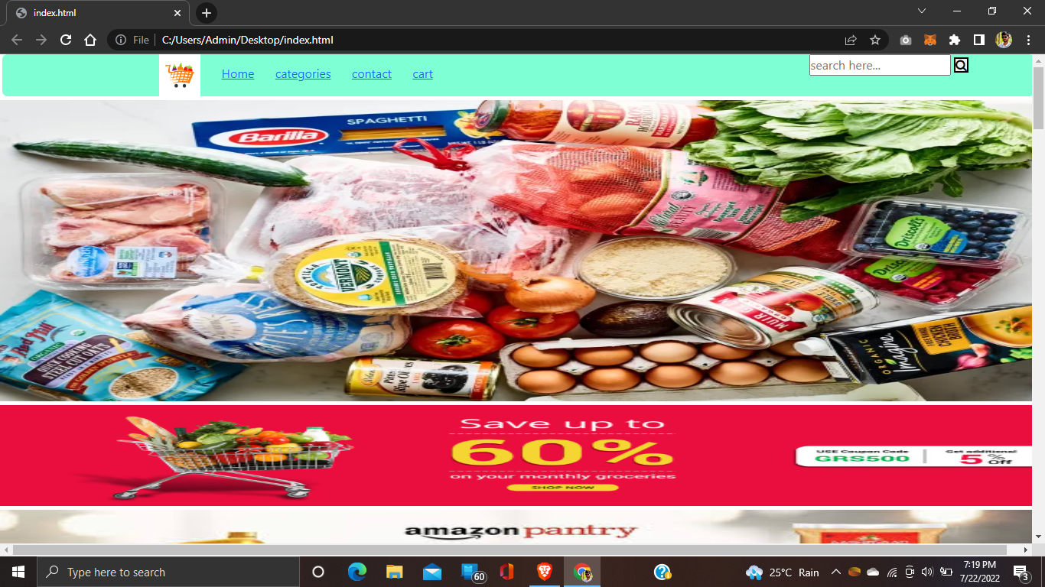

Fig 9.1 : Home Page

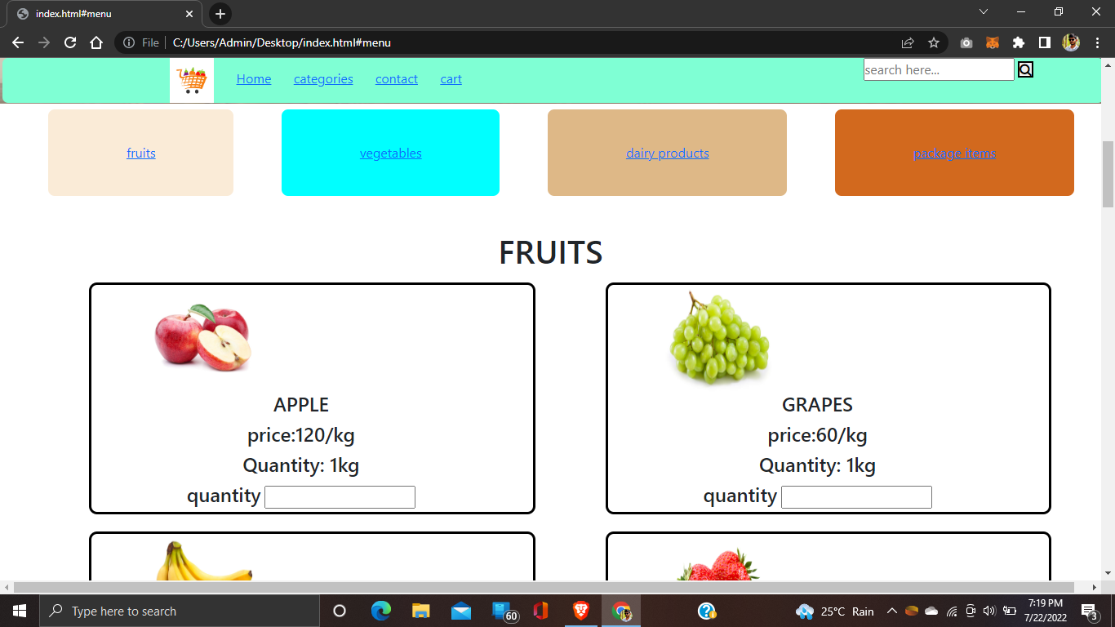

Fig 9.2 : Categories

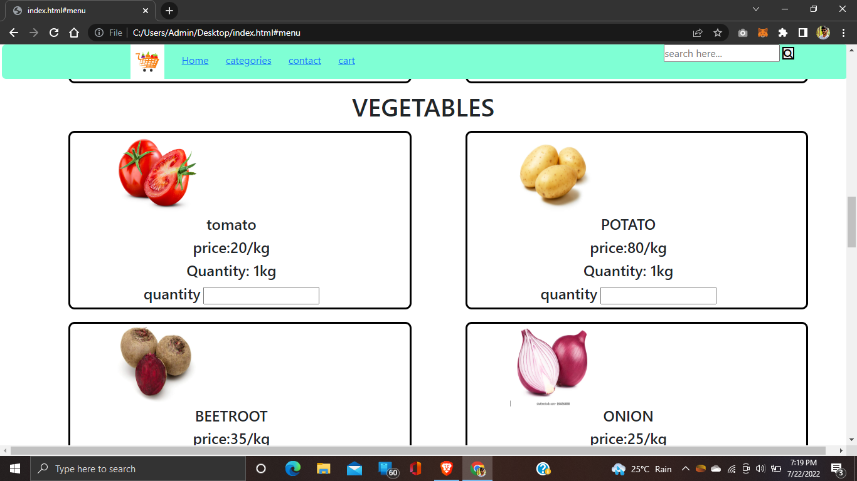

Fig 9.3 : Categories

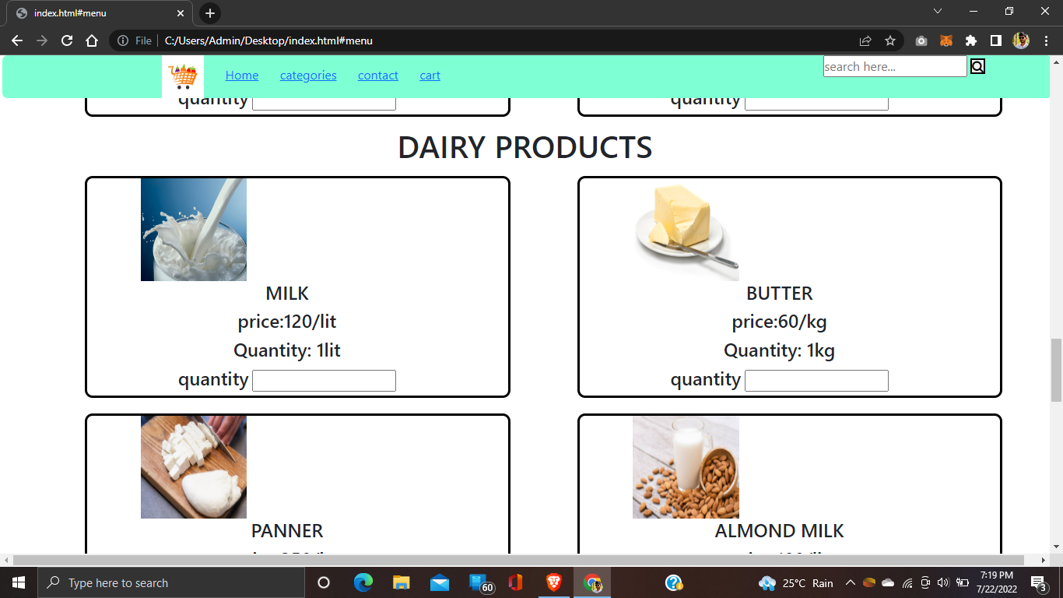

Fig 9.4 : Categories

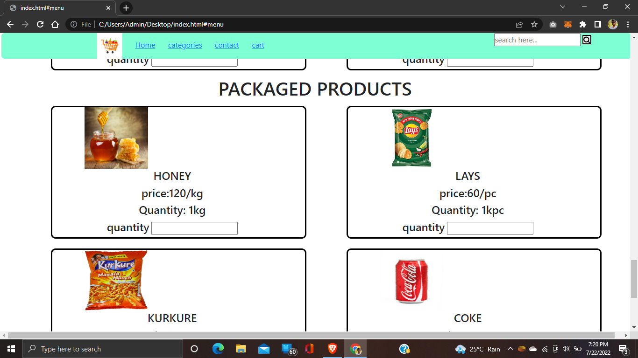

Fig 9.5 : Categories

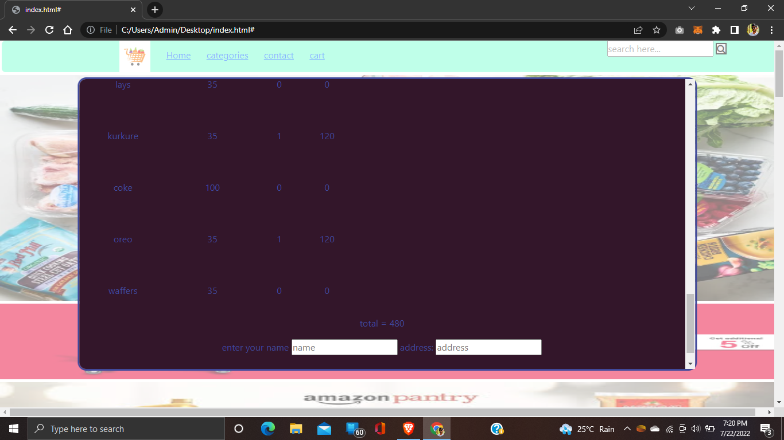

Fig 9.6 : Cart

**Chapter 10:**

**CONCLUSION AND FUTURE ENHANCEMENTS**

The project entitled Online shopping system was completed successfully. The system has been developed with much care and free of errors and at the same time it is efficient and less time consuming. The purpose of this project was to develop a web application and an android application for purchasing items from a shop.

This project helped us in gaining valuable information and practical knowledge on several topics like designing web pages using html & css, usage of responsive templates, designing of android applications, and management of database using mysql . The entire system is secured. Also the project helped us understanding about the development phases of a project and software development life cycle. We learned how to test different features of a project.

This project has given us great satisfaction in having designed an application which can be implemented to any nearby shops or branded shops selling various kinds of products by simple modifications.

There is a scope for further development in our project to a great extend. A number of features can be added to this system in future like providing moderator more control over products so that each moderator can maintain their own products. Another feature we wished to implement was providing classes for customers so that different offers can be given to each class. System may keep track of history of purchases of each customer and provide suggestions based on their history. These features could have implemented unless the time did not limited us.

**REFERENCES**

1. [https://geeksforgeeks.com](https://geeksforgeeks.com/)
2. [https://javatpoint.com](https://javatpoint.com/)
3. [https://w3cschools.com](https://w3cschools.com/)
4. [https://stackoverflow.com](https://stackoverflow.com/)
5. <https://devdocs.io/>